Maven Vs Grade comparisions
Maven is best for standardized, predictable enterprise builds, while Gradle excels in speed, flexibility, and modern multi-project environments. Maven uses XML with a fixed lifecycle, whereas Gradle leverages Groovy/Kotlin DSL with incremental builds and caching, often cutting CI/CD times significantly.
⚙️ Core Comparison
 | MavenXML-based, fixed lifecycle | GradleGroovy/Kotlin DSL, flexible
Configuration
Language | XML (pom.xml) | Groovy/Kotlin DSL (build.gradle)
Style | Declarative | Imperative + declarative
Performance
Build Speed | Slower (no incremental builds) | Faster (incremental + parallel builds)
Caching | Minimal | Advanced task & artifact caching
Dependency
Version Handling | Fixed versions only | Dynamic versions supported
Conflict Resolution | Nearest definition wins | Newest version wins (configurable)
Ecosystem
Plugins | Mature, extensive | Large, growing
Community | Enterprise-focused | Android + JVM strong
Best Use | Enterprise, reproducible builds | Android, large monorepos, CI/CD
Sources:
🚀 Practical Takeaways
- Maven → Ideal for enterprise pipelines, reproducibility, and teams needing strict version control.
- Gradle → Best for Android apps, large JVM monorepos, and CI/CD pipelines where caching and incremental builds save time.
🧩 Example Snippets
Maven
xml
<dependency>
<groupId>org.springframework.boot</groupId>
<artifactId>spring-boot-starter-web</artifactId>
<version>3.2.5</version>
</dependency>
Gradle
groovy
implementation 'org.springframework.boot:spring-boot-starter-web:3.2.+'
➡ Gradle automatically picks the latest compatible patch version.
Maven vs Gradle build flow diagram
Here’s a Maven vs Gradle build flow diagram that highlights how each tool orchestrates builds differently:
🧩 Build Flow Comparison
Stage | Maven | Gradle
Config File | Reads pom.xml (XML, declarative) | Reads build.gradle (Groovy/Kotlin DSL, scriptable)
Lifecycle | Fixed phases (validate → compile → test → package → install → deploy) | Flexible tasks graph, dynamically resolved
Execution | Sequential tasks → slower builds | Parallel tasks → faster builds
Dependency Resolution | Static XML tree, nearest-definition wins | Dynamic graph, newest-version wins (configurable)
Caching | Minimal; downloads each artifact if missing | Advanced caching; reuses tasks/artifacts locally & remotely
Build Output | Predictable, reproducible builds | Optimized, incremental builds
⚙️ Conceptual Flow Diagram
Code
Maven: pom.xml → Lifecycle Phases → Sequential Tasks → Build Output
Gradle: build.gradle → Task Graph → Parallel Execution + Caching → Build Output
Optimized Takeaway
- Maven → predictable, stable builds with strict version locking — best for enterprise consistency.
- Gradle → faster, flexible builds with caching and dynamic resolution — best for modern CI/CD pipelines and large projects.
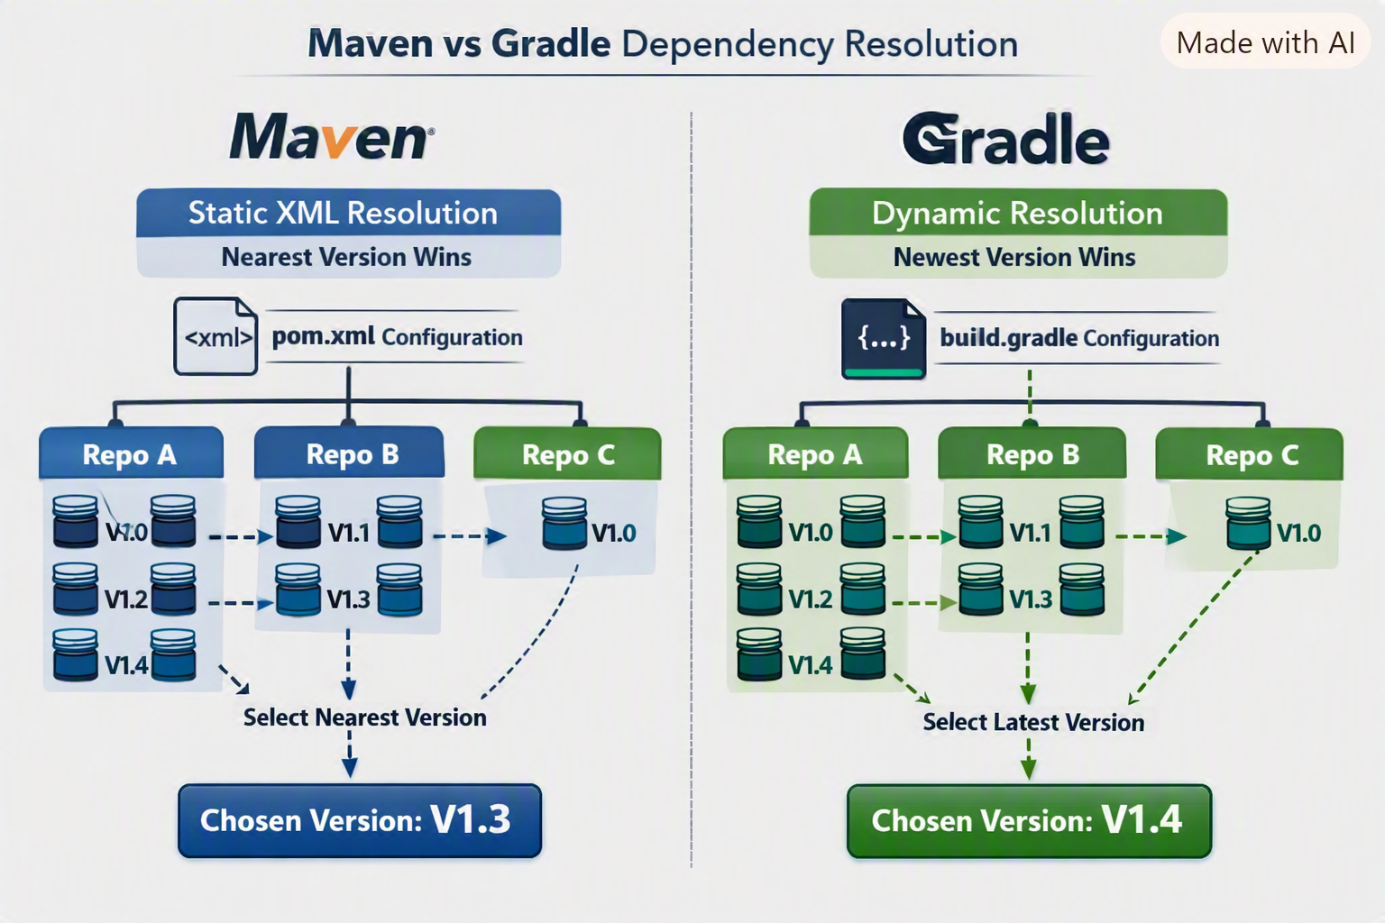

Here’s the Maven vs Gradle dependency resolution diagram you asked for — it visually contrasts how Maven’s nearest-definition strategy differs from Gradle’s newest-version approach.
https://copilot.microsoft.com/th/id/BCO.9a424823-06a4-4e2c-84ad-f2c2ef26f735.png
⚙️ Key Insights
- Maven → Resolves dependencies via a static XML tree (pom.xml), selecting the nearest version in the hierarchy.
- Gradle → Builds a dynamic graph (build.gradle), preferring the newest version unless overridden.
- Caching → Maven has minimal caching, while Gradle aggressively reuses tasks/artifacts for faster builds.
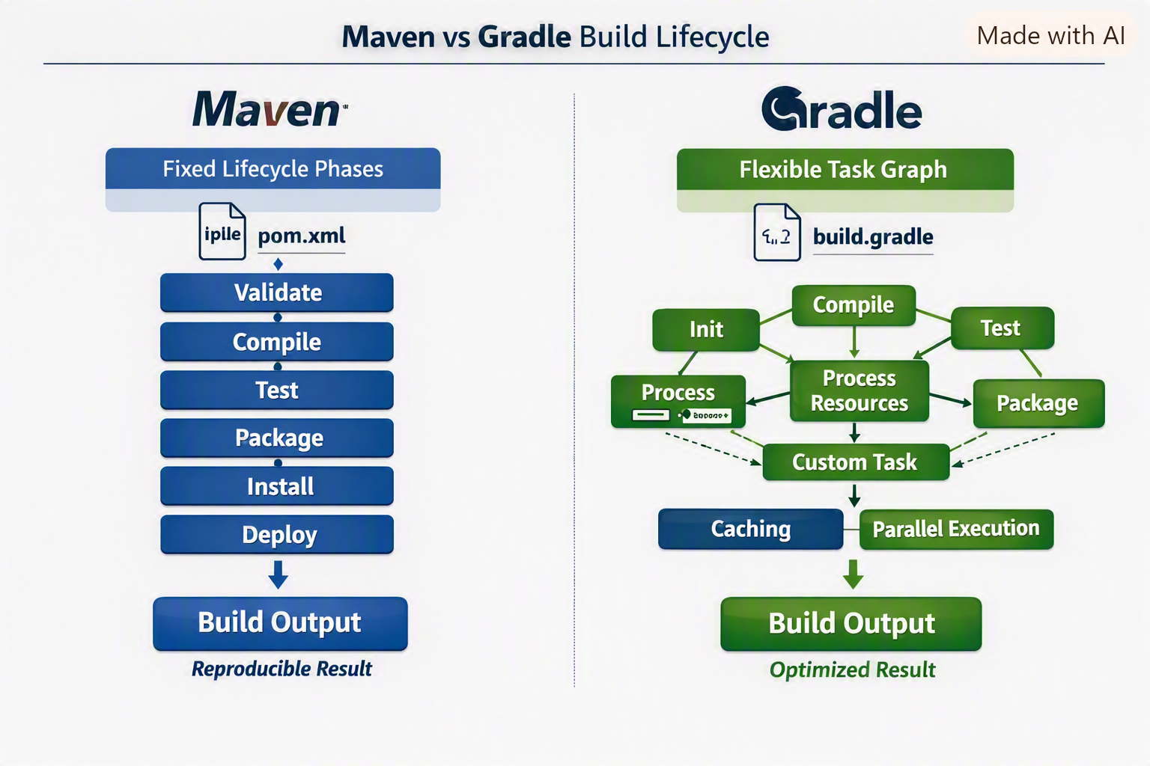

Here’s the Maven vs Gradle build lifecycle diagram — it visually contrasts Maven’s fixed lifecycle phases with Gradle’s flexible task graph.
🔗 View full diagram
⚙️ Key Insights
- Maven → Sequential, predefined phases (validate → compile → test → package → install → deploy) ensure reproducibility.
- Gradle → Dynamic task graph allows parallel execution, caching, and custom task injection for optimized builds.
- Performance → Gradle’s incremental builds and daemon reuse make it faster for large projects.
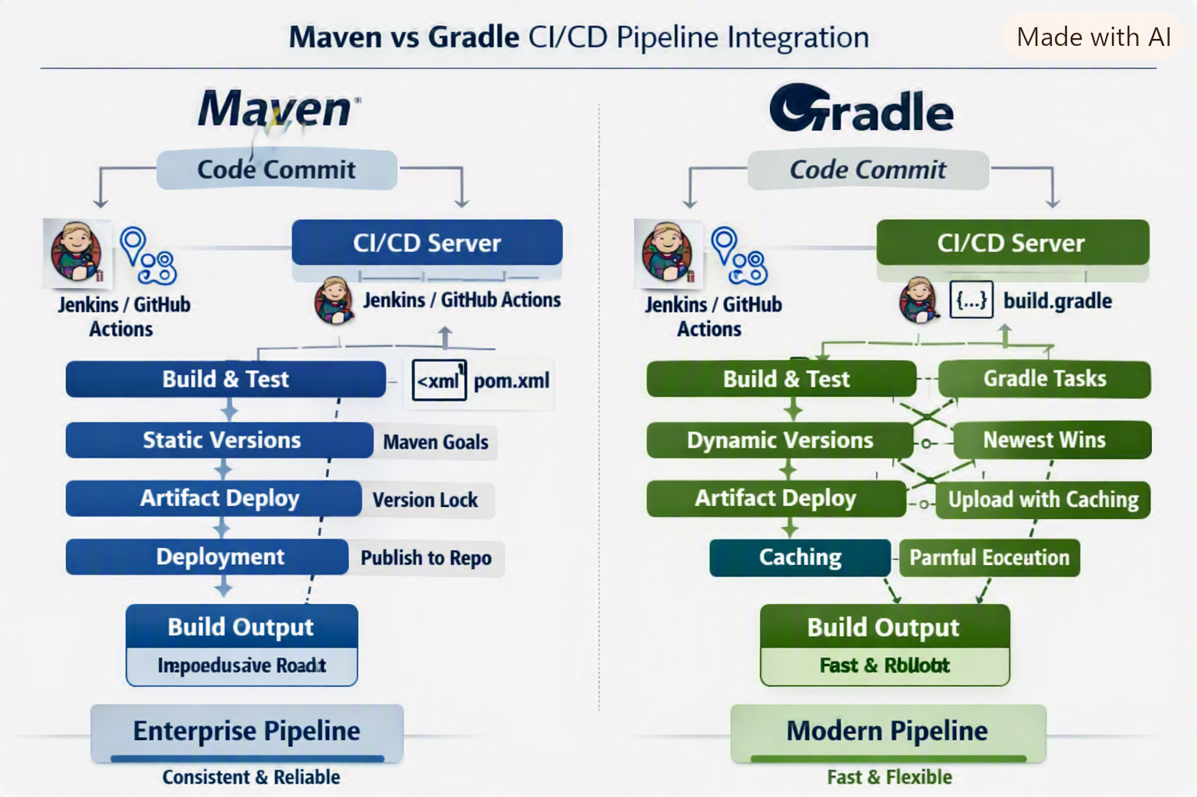

Here’s the Maven vs Gradle CI/CD pipeline integration diagram — it visually compares how each tool fits into Jenkins or GitHub Actions workflows.
🔗 View full diagram
⚙️ Key Insights
- Maven → Uses fixed goals (clean, install, deploy) with version locking, ensuring consistent enterprise releases.
- Gradle → Employs dynamic tasks and caching for faster builds and flexible rollouts.
- Integration → Both tools plug seamlessly into Jenkins and GitHub Actions, but Gradle’s incremental builds reduce pipeline time significantly.
Here’s a Maven vs Gradle Kubernetes deployment flow diagram — it shows how each build tool integrates with containerization and orchestrates microservices deployment into Kubernetes clusters.
🔗 View full diagram (copilot.microsoft.com in Bing)
⚙️ Key Insights
- Maven →
  - Builds artifacts via fixed lifecycle (compile → package → deploy).
  - Pushes version-locked JAR/WAR files into Docker images.
  - Publishes to container registry (e.g., Azure Container Registry, Docker Hub).
  - Kubernetes applies manifests with stable, reproducible deployments.
- Gradle →
  - Uses dynamic task graphs with caching for faster builds.
  - Generates Docker images with incremental layers.
  - Publishes artifacts with flexible versioning (latest.release, 1.+).
  - Kubernetes applies manifests with rolling updates and parallel scaling.
🚀 Optimized Takeaway
- Maven → Best for enterprise stability, strict version control, and predictable deployments.
- Gradle → Best for fast rollouts, incremental updates, and modern CI/CD pipelines with Kubernetes autoscaling.
Here’s how Maven vs Gradle Helm chart integration works when packaging microservices for Kubernetes deployment:
⚙️ Key Insights
- Maven →
  - Uses plugins (e.g., fabric8-maven-plugin) to build Docker images.
  - Helm charts are generated from static XML configurations.
  - Ensures reproducible deployments with strict version locking.
  - Best suited for enterprise stability and predictable rollouts.
- Gradle →
  - Leverages dynamic task graphs and caching for faster builds.
  - Helm charts can be templated with flexible versioning (latest.release, 1.+).
  - Supports parallel builds across microservices.
  - Optimized for fast rollouts and modern CI/CD pipelines.
🚀 Optimized Takeaway
- Maven → Helm integration emphasizes consistency and reproducibility.
- Gradle → Helm integration emphasizes speed and flexibility.

